**To:** **Dr. David Willy; Husain Sodawalla**

**From:**  **Northrop Grumman Capstone Team**

**Date:** **12-8-23**

**Re:** **Project Management Memo**

**Introduction**

As the first semester of effort and work finishes, the Northrop Grumman Drill Arm team has compiled a list of both reflections on this initial effort and ideas on how future efforts should be conducted. This memo will serve as the team’s final assignment together for the semester, setting the project up for success in the second semester of effort by outlining what work has been done, what work is left to be done, what has been learned from this past semester, and how the team should go about completing the final semester’s worth of work. These plans will be laid out in the form of a reflection on the last semester, the successes seen by the team, the areas which could be improved upon, tasks which still need to be accomplished, remaining design efforts, a rough Gantt chart of what the tasks will be coming into next semester, a purchasing plan, and a manufacturing plan.

**Reflection**

Overall, this semester was successful but there were times that could have been better for the team. The team worked well together which will be great carrying forward into next semester. Everyone on the team had their roles and if someone needed help there was always another teammate that would. All reports and presentations went well throughout the semester, giving the audience a strong idea of what the team was doing and trying to accomplish. One thing the team struggled with was the prototype one, in which there were problems with the electronics and code which made the robot not move. The team took that as a learning point to then create a very successful prototype two. Based on this semester, moving forward the team just needs to work on meeting all together more often for the large deliverables and also start those tasks more ahead of the due date.

**Successes**

Throughout this semester the Northrop Grumman team found its most success in presentation and prototyping. One of the team's most important presentations was to the team's sponsor, Northrop Grumman. This presentation was a preliminary design report which covered everything that the team had done up to that point. Which included benching marking, calculations, budgeting, system models, and concept selection. The employees of Northrop Grumman were impressed with what the team had done at that point. Another major accomplishment the team had was prototype two which were able to learn a lot from prototype one. The team was able to accomplish a robotic arm that had the ability to move with two degrees of freedom. That movement was controlled by a code that corresponded to keyboard buts that moved the robot up, down, out, and in. This prototype was a huge step in the right direction for the team now being able to control the robot.

**Room for Improvements**

Within this list there are a few things that the team can improve on going into the next semester, these improvements can help with the team's overall success. Although the team has done great thus far in regard to designing this robotic drilling arm there is always room for improvement.

* More communication between all members of the team
* Having all members be at team meetings more often
* Be more prepared for assignments that take longer than expected.
* The entire team needs to work on coding skills.
* Apply more pressure to companies that could donate to the team.

**Action Items**

1. **Receive donations toward 10% fundraising goal.** 
   1. This will help the team by more products going toward the final design.
2. **Team members need to be machine shop certified.**
   1. To ensure different members in the design are made in a timely manner and not having to wait for someone else to make the parts.
3. **Start ordering parts that will be within the final design.**
   1. This will ensure that the team has all parts without feeling pressure of time toward the end of the semester.
4. **Reach out to NAU to make sure our Northrop Grumman budget is being used.**
   1. This will take time and if we do not do this soon, we will run out of time.
5. **Tell Northrop Grumman that we need to have more constructive criticism.**
   1. Although Northrop Grumman has assisted the team more constructive criticism will help the team to be successful instead of hearing that we are doing a great job on everything
6. **Document the overall design and building process.**
   1. The team needs to be taking more videos and pictures of the design process to show Northrop Grumman as well as have pictures for the website gallery.
7. **Finalize all design criteria to ensure the team is on the same page.**
   1. Finalizing all important information within the design will help the team moving forward and allow for the team to have a cohesive and well-made design.
8. **Be more communicative with Northrop Grumman clients.**
   1. The team meets with Northrop Grumman biweekly although the information that the clients say that they will provide are often not followed through with. Even though the team will not depend on this information it would be nice to have going further.
9. **Be prepared for the CDR presentation to Northrop Grumman**
   1. Being more prepared for this presentation will help the team have more success going forward as well as potentially coincide with a capstone assignment that can be switched out with the presentations.

**Remaining Design Efforts**

* Machine all members of the design that are necessary.
* Order all hardware, motors, drives, for final design.

**Gantt Chart**

As can be seen in Table 1 below, the taskings to be completed by the team from Week 1 all the way to the first Hardware Update may be few, but nonetheless are still critical to the success of the project throughout the remainder of the semester.

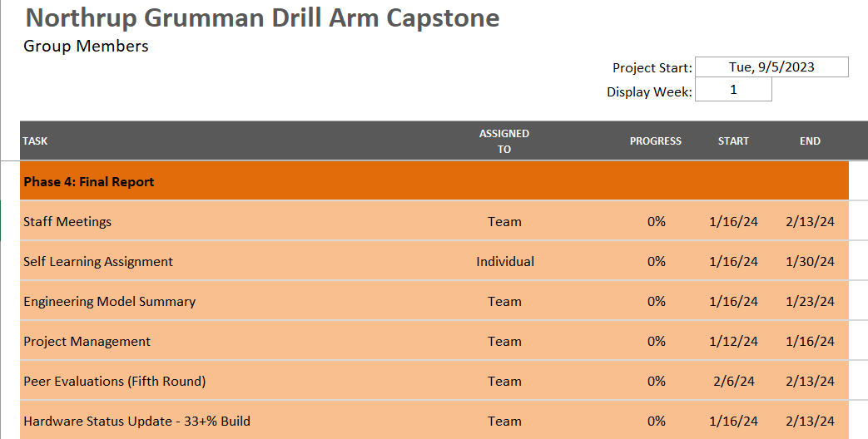

Table 1: Rough Gantt Chart for Second Semester

* Peer Evaluations: A peer evaluation will be conducted at the end of this period of work to give the team an opportunity to provide one another with feedback.
* Self Learning Assignment: A secondary self learning assignment, similar to those undertaken in the first semester, will be given to the team to complete in everyone's own time. These will further the overall project in some way, shape, or form, through calculations and analysis.
* Engineering Model Summary: The Engineering Model Summary will be led by our CAD and Manufacturing Engineers, Russel Stringham and Brandon Knutson, respectively. This will help the team understand exactly where the product is and what else, if anything, needs to be done to make it ready for manufacturing.
* Project Management: This Project Management memo will be referenced by the team during the beginning week of the semester to ascertain whether any changes need to be made and to give everyone a refresher on the plan.
* Staff meetings, as always, will be in place for the team to come together and give important updates, make plans, and adjust taskings if necessary. Something not shown but that could ideally be accomplished during this period would be to get most if not all the team certified for machine shop tool usage.

**Purchasing Plan**

There are several components that have been selected for the final product that will take significant planning prior to their purchase. The most expensive item is the slewing drive. This essential part of the robot is priced at nearly 2000 dollars and has a lead time of about four weeks. The team is currently in contact with a slewing drive manufacturer called SlewPro to possibly receive a discount on the drive to apply towards the team’s fundraising goal. The next component that the team will need to purchase is the spindle. The spindle that the team has selected costs about 100 dollars and will take two weeks from order to arrival. The purchase orders for both the spindle and the slewing drive are currently being completed and will be filed with Northrop Grumman as well as the NAU engineering department before the new year. The Nema 34 stepper motors and the gear boxes that will be needed for the design cost a total of 490 dollars and have a lead time of two weeks. As of now this is the planned course of action for controlling the movement of the robotic arms, however, will not be confirmed until the most accurate power requirements are calculated. The final decision and purchase order for these components will occur in the first week of the next semester.

All electronic components, motor drivers, and magnetic encoders will also be purchased in the first week of the next semester. Additionally, raw materials that require some sort of manufacturing process will also be ordered in the first week of the next semester to allow for the maximum amount of manufacturing time. As the team is still considering options for the pulley system that will actuate the movement of the arms from the motors, more research needs to be done prior to the purchasing of these items. These calculations will be completed by week two of the next semester, with selection and purchase of these items occurring no later than week three. All other necessary components including bearings, hardware, and excess electronic items will be purchased “as needed”. The required parts that have a lead time more than one week will be purchased no later than week four of the next semester.

**Manufacturing Plan**

For the manufacturing of the system, we are aware of several oversights in our design and know that some design revisions are in order especially for the belt power transmission system and the main shaft for the lower shank and power output. We will allot at maximum two weeks for this redesign however we will start manufacturing the linkages, triplates and shanks as soon as possible. All these items have critical hole positions which will be done by team members on the end mills and the outer shapes on either the bandsaw or with an angle grinder. This is because the outside dimensions of our system are not critical to the design. As for the shaft and power transmission our method of design will depend on our final decision but will be pushed towards simplicity so the design can be done by team members and not require help from machine shop managers. As for the base of the design, the system will have to be done by a machine shop manager because of its complexity. Welding will also most likely be required, which is a skill that needs to be learned by one or more of the team members.

**Conclusion**

The work performed by the team this semester is at a satisfactory level, with many successes and multiple lessons learned. The team is aware of some areas of improvement going forward, such as the commitment level and involvement in the project. As observed by Professor Willy, the team has not been working as a cohesive unit. The individual research completed by the team members has not come together to make genuine progress. However, the team will continue to strive for unity in the work being completed. The team also needs to get ahead on the purchasing plan prior to the next semester. Getting ahead on this part of the project will allow for more when the inevitable setbacks occur. With the newly updated Gantt chart, the team can quickly get going at the start of the next semester and waste little time trying to remember what exactly needs to be done. The manufacturing and purchasing plans will also aid in this fashion, as they too will provide the team with a solid plan as to what needs to be done next. With all of this in mind and put together in one memo, the team can return next semester with confidence to complete the work begun on Northrop Grumman’s drill arm this semester.